**Impacts of Covid-19 and Securing**

**the Delivery of Higher-Education.**

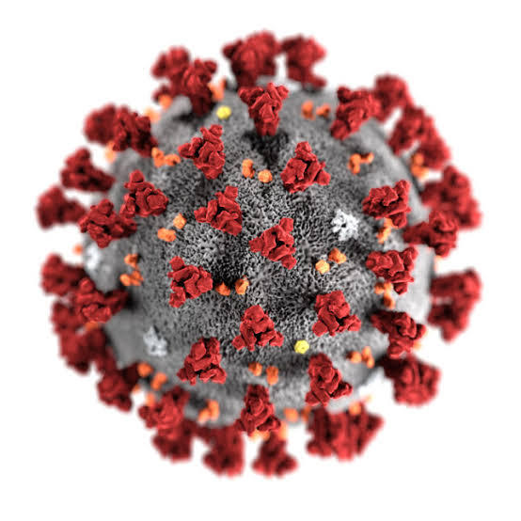

Prepared for: Otago Polytechnic

School/Department of Business, Tourism and IT

Prepared By

Saniya, Mohammed, Toni, Anthony and Joseph

March 30, 2020

Impacts of Covid-19 and Securing the Delivery of Higher-Education.

**Summary**

Impacts of Covid-19 and Securing the Delivery of Higher-Education.

**Contents**

**Introduction & Covid-19** 4

**Ongoing Student Support and Engagement.** 4

**Ongoing course delivery, testing and assignments** 4

**Data access and availability** 4

**Software Applications and Delivery of Content** 4

Criteria 4

Features 4

Disadvantages 4

Set-up 4

Accessibility 4

Data use 4

Ease of use 4

**Recommendations/conclusion** 4

**References** 4

Impacts of Covid-19 and Securing the Delivery of Higher-Education.

## **Introduction & Covid-19**

## **Ongoing Student Support and Engagement.**

## **Ongoing course delivery, testing and assignments**

## **Data access and availability**

## **Software Applications and Delivery of Content**

### Criteria

### Features

### Disadvantages

### Set-up

### Accessibility

### Data use

### Ease of use

## **Recommendations/conclusion**

## **References**